Clinical Supervision Training

The training is designed to meet the 25-hour requirement for individuals seeking qualification as a LPC Board Approved Supervisor (LPC-S)



2021

Anthony J. Williams, LPC-S, LMFT, NCC

Williams Counseling Services of Shreveport, LLC

**Clinical Supervision Training**

**Registration Options**

**Register by mail**

(Use the attached registration form)

**Register online**

(Send registration form to *tony4897h@aol.com*)

For registration or content questions, call Anthony J. Williams, LPC-S, LMFT, NCC, at the following numbers: 318 393-8449 or 318 219-9508.

The training is designed to meet the 25-hour requirement for people seeking qualification as a LPC Board Approved Supervisor (LPC-S). Participants will receive 25 LPC CEU contact hours with 3 hours in Ethics. The training is divided into two parts, both of which are required.

Each **participant will be required to hold two supervision sessions with another professional between Part I and Part II. They are to videotape the sessions to be reviewed and critiqued during Part II.**

***The Louisiana Counseling Association is approved by the Louisiana Licensed Professional Counselors Board of Examiners to offer continuing education for Louisiana Licensed Professional Counselors and Provisional Licensed Professional Counselors. This program meets requirements up to 25.0 continuing education clock for Louisiana Licensed Professional Counselors.***

**Clinical Supervision Training Dates and Times**

The training will be held four times during the year to allow for flexibility. The proposed dates are:

**Part I – March 26-27, 2021**

**Part II – April 16-17, 2021**

**Part I – June 4-5, 2021**

**Part II – July 2-3, 2021**

**Part I – September 3-4, 2021**

**Part II – October 1-2, 2021**

**Part I – November 5-6, 2021**

**Part II – December 3-4, 2021**

**Part I**

**Day 1**

Models of Supervision (Part I) 8:00am – 10:00am

Break 10:00am – 10:15am

Models of Supervision (Part II) 10:15am – 11:45am

Lunch 11:45am – 1:00pm

Counselor Development (Part I) 1:00pm – 2:30pm

Break 2:30pm – 2:45pm

Counselor Development (Part II) 2:45pm – 4:30pm

**Day 2**

Supervision Methods and Techniques (Part I) 8:00am – 10:00am

Break 10:00am – 10:15am

Supervision Methods and Techniques (Part II) 10:15am – 11:45am

Lunch 11:45am – 1:00pm

Supervisory Relationship (Part I) 1:00pm – 2:30pm

Break 2:30pm – 2:45pm

Supervisory Relationship (Part II) 2:45pm – 4:30pm

**Part II**

**Day 3**

Ethical, Legal, and Professional Regulatory Issues (Part I) 8:00am – 10:00am

Break 10:00am – 10:15am

Ethical, Legal, and Professional Regulatory Issues (Part II) 10:15am – 11:45am

Lunch 11:45am – 1:00pm

Evaluation (Part I) 1:00pm – 2:30pm

Break 2:30pm – 2:45pm

Evaluation (Part II) 2:45pm – 4:30pm

**Day 4**

Review of Videotaped Supervision Sessions (Part I) 8:00am – 10:00am

Break 10:00am – 10:15am

Review of Videotaped Supervision Sessions (Part II) 10:15am – 11:45am

Lunch 11:45am – 1:00pm

Executive (Administrative) Skills (Part I) 1:00pm – 2:30pm

Break 2:30pm – 2:45pm

Executive (Administrative) Skills (Part II) 2:45pm – 4:30pm

All training will occur *virtually* at Williams Counseling Services of Shreveport, LLC, 7505 Pines Road, Suite 1292-A, Shreveport, LA 71105.

**Training Fees**

The fee is $300.00 for the training. Advanced registration is recommended. Refunds must be applied for at least seven (7) days before the start of each proposed starting session. A $50.00 handling fee is non-refundable.

**Training Objectives**

* To define and conceptualize supervision and models of supervision
* To understand and effectively utilize the stages of counselor development
* To increase knowledge of supervision methods and techniques
* To develop an effective supervisory relationship
* To understand the ethical, legal, and professional regulatory issues
* To examine the role of evaluation in supervision
* To develop executive (administrative) skills in supervision

**Recommended Reading Materials**

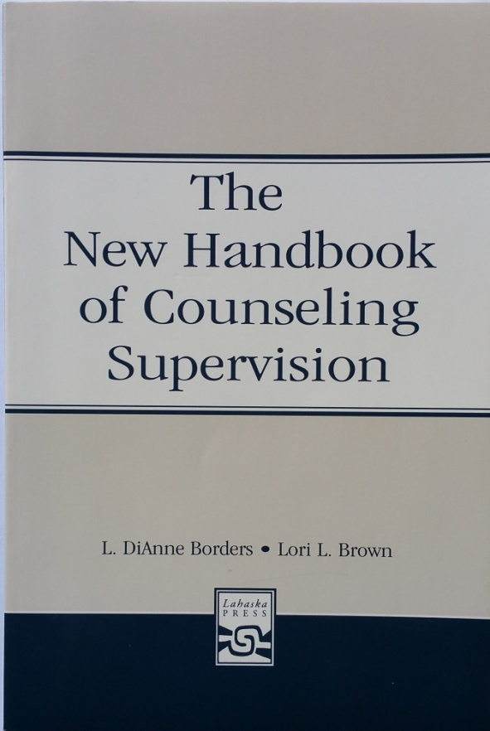

Borders, L D., Brown L. L., (2005). *The new handbook of counseling supervision*. Mahway, New Jersey: Association for Counselor Education and Supervision.

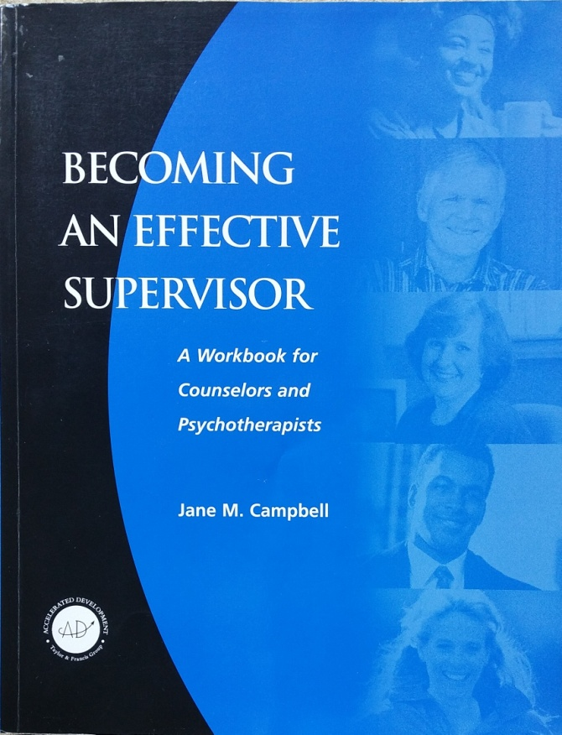

Campbell, J. M. (2000). *Becoming an effective supervisor.* Ann Arbor, MI.: Taylor and Francis.

Anthony J. Williams, LPC-S, LMFT, NCC, is a Licensed Professional Counselor in full-time private practice and has been a Board Approved Supervisor since 1997. He is a retired Air Force veteran and has been a certified bereavement facilitator since 1998. He has provided bereavement training services to area agencies as well as several church groups. Mr. Williams also conducts groups for anger management, self-esteem, adolescents, and effective parenting. He is a member of the American Counseling Association, the Louisiana Counseling Association, and the Northwest Louisiana Counselors Group. Mr. Williams also provides ongoing monthly training sessions for LPC Supervisors and PLPCs through the Northwest Louisiana Supervisors’ Group.



**Presenter**

**Clinical Supervision Training**

Registration Fee: $300.00

Please make all checks payable to:

***Williams Counseling Services of Shreveport, LLC***

All participants should register in advance by telephone or mail to Anthony J. Williams at:

**Williams Counseling Services of Shreveport, LLC**

**7505 Pines Road Suite 1292**

**Shreveport, LA 71105**

Name: ____________________________________________________

Address: ________________________________________________

City/State: ____________________________________________

Telephone: ______________________

Email: ____________________________________________________

Will any special provisions be needed?